

**Green University of Bangladesh**

**Department of Computer Science and Engineering (CSE)**

**Faculty of Sciences and Engineering**

**Semester: (Fall, Year: 2024), B.Sc. in CSE (Day)**

**Lab Report NO: 01**

**Course Title: Data Structure Lab**

**Course Code: CSE 206**

**Section: D8**

**Lab Experiment Name:** Basic operations of one-dimensional and two-dimensional array

**Student Details**

|  |  |  |
| --- | --- | --- |
| **Name** | | **ID** |
| **1.** | Ashab Uddin | 232002274 |

**Lab Date : 04/09/24**

**Submission Date : 11/09/24**

**Course Teacher’s Name : Md. Parvez Hossain**

|  |
| --- |
| **Lab Report Status**  **Marks: ………………………………… Signature: .....................**  **Comments: .............................................. Date: ..............................** |

1. **INTRODUCTION**

The purpose of this lab report is to thoroughly understand array concepts in C programming. We will cover operations such as adding, deleting, inserting, and finding duplicate numbers in one-dimensional arrays, as well as performing addition operations in two-dimensional arrays. The goal is to apply these techniques to solve real-world problems efficiently, demonstrating the practical application of array manipulation in programming.

1. **OBJECTIVES**

• To understand how to perform addition, deletion, and insertion operations in a one-dimensional array.

• To learn how to identify and handle duplicate numbers within an array.

• To explore the method for adding two-dimensional arrays.

**3. IMPLEMENTATION**

**Task 1:** Write a program in C to add a value at any index of an array.

**Solution:**

#include<stdio.h>

int main(){

    int a[50],size,num,index,i;

    printf("Enter the size of an array: ");

    scanf("%d",&size);

    printf("Enter the %d elements of an array: ",size);

    for (int i=0; i<size; i++){

        scanf("%d",&a[i]);

    }

    printf("Enter the number you want to insert: ");

    scanf("%d",&num);

    printf("Enter the index: ");

    scanf("%d",&index);

    for (int i=size-1; i>=index; i--){

        a[i+1] = a[i];

    }

    a[index] = num;

    size++;

    printf("Here is the Final array element: ");

    for ( i = 0; i<size; i++){

        printf("%d ",a[i]);

    }

    return 0;

}

**Output:**

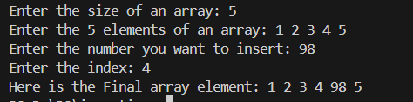

**Task 2:** Write a program in C to delete a value at any index of an array.

**Solution:**

#include<stdio.h>

int main(){

    int lb,ub;

    int A[100];

    printf("Enter the lb: ");

    scanf("%d",&lb);

    printf("Enter the ub: ");

    scanf("%d",&ub);

    printf("Enter the element of an array: ");

    for(int i = lb; i<=ub; i++){

        scanf("%d",&A[i]);

    }

    printf("The array is: ");

    for (int i=lb; i<=ub; i++){

        printf("%d ",A[i]);

    }

    printf("\n");

    int p;

    printf("Enter the position you want to delete: ");

    scanf("%d",&p);

    for(int i =p; i<=ub; i++){

        A[i] = A[i+1];

    }

    ub --;

    printf("The New array is: ");

    for(int i =lb; i<=ub; i++){

        printf("%d ",A[i]);

    }

    return 0;

}

**Output:**

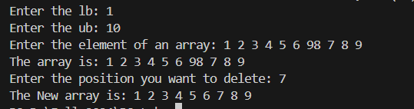

**Task 3:** Write a program in C to insert a value at any index of an array.

**Solution:**

#include<stdio.h>

int main(){

    int lb,ub;

    int A[100];

    printf("Enter the lb and ub of the array: "); //lb = lower bound and ub = upper bound

    scanf("%d %d",&lb,&ub);

    printf("Enter the element of an array: ");

    for(int i =lb; i<=ub; i++){

        scanf("%d",&A[i]);

    }

    printf("The Entered Array is: ");

    for(int i =lb; i<=ub; i++){

        printf("%d ",A[i]);

    }

    printf("\n");

    int p;

    printf("Enter the position where you want to insert: ");

    scanf("%d",&p);

    int value;

    printf("Enter the value where you want to insert: ");

    scanf("%d",&value);

    A[p] = value;

    printf("The New array is: ");

    for(int i= lb; i<=ub; i++){

        printf("%d ",A[i]);

    }

    return 0;

}

**Output:**

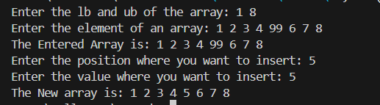

**Task 4:** Write a program in C to count the total number of duplicate elements in an array.

**Solution:**

#include <stdio.h>

int main() {

    int A[100];

    int lb, ub;

    printf("Enter the lb and ub of the array:\n");

    scanf("%d %d", &lb, &ub);

    printf("Input elements of the array:\n");

    for (int i = lb; i <= ub; i++) {

        scanf("%d", &A[i]);

    }

    printf("The Array: ");

    for (int i = lb; i <= ub; i++) {

        printf("%d ", A[i]);

    }

    printf("\n");

    int dup[100]={0};

    for (int i = lb; i <= ub; i++) {

        for (int j = lb; j <= ub; j++) {

            if (i==j) {

                break;

            }

            else if(A[i]==A[j]){

                dup[i] = 1;

            }

        }

    }

    int sum =0;

    for(int i=lb;i<=ub;i++){

            sum +=dup[i];

    }

    printf("Total number of duplicate elements: %d\n", sum);

    return 0;

}

**Output:**

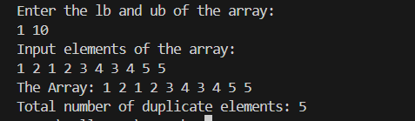

**Task 5:** Write a program in C for adding two matrices of the same size.

**Solution:**

#include<stdio.h>

int main(){

    int A[20][20],B[20][20],C[20][20];

    int i,j, rA, cA, rB, cB;

    printf(" Enter the Number of rows and colums in A Matrix:\n");

    scanf("%d %d",&rA,&cA);

    printf("Enter the Number of rows and colums in B Matrix:\n");

    scanf("%d %d",&rB,&cB);

    printf("Enter the elements of A matrix: \n");

    for(i=0;i<rA;i++){

        for(j=0;j<cA;j++){

            printf("A[%d][%d]= ",i,j);

            scanf("%d",&A[i][j]);

        }

    }

    printf("\n");

    printf("Enter the elements of B matrix: \n ");

    for(i=0;i<rB;i++){

        for(j=0;j<cB;j++){

            printf("B[%d][%d]= ",i,j);

            scanf("%d",&B[i][j]);

        }

    }

    for(i=0;i<rA;i++){

        for(j=0;j<cB;j++){

            C[i][j]= A[i][j]+B[i][j];

        }

    }

    printf("Result:\n");

    for(i=0;i<rA;i++){

        for(j=0;j<cB;j++){

            printf("%10d",C[i][j]);

        }

        printf("\n");

    }

    return 0;

}

**Output:**

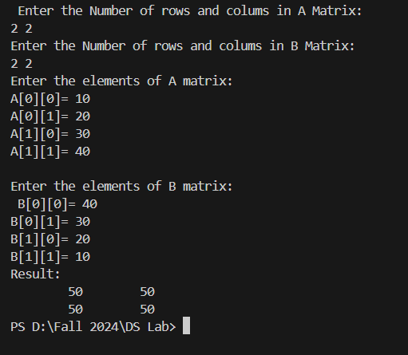

1. **DISCUSSION**

In this lab, we worked on various tasks involving arrays, including addition, deletion, insertion, shifting, finding duplicates, and summing 2D matrices.

For insertion, we added a new element at a given index by shifting the other elements to the right. Deletion was done by shifting elements to the left to remove the selected element, and the array size was reduced accordingly. In the shifting task, we rearranged values in the array either left or right based on the given position.

We also learned to find duplicate numbers by counting how many times each element appeared in the array. For example, if the number 1 appeared three times, the output would show 2 duplicates. Lastly, adding two 2D matrices of the same size involved summing the corresponding elements from both matrices using a simple loop. Each of these tasks gave us a clear understanding of how arrays can be manipulated in different ways.